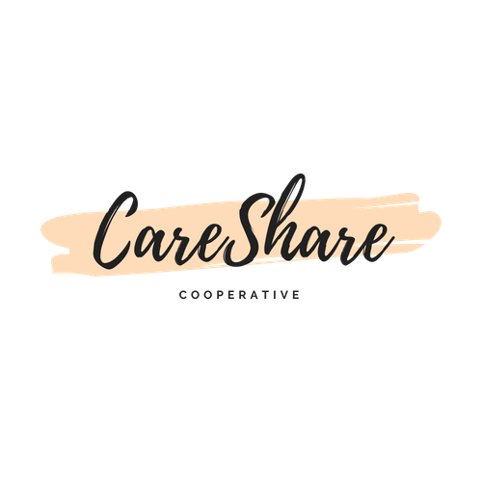
CareShare STAFF
The CEO, Susan Stai, began her work for CareShare on June3. The job description is simple, to take the work that has been accomplished by the CareShare organizing committee as well as CUCI, and make it work.
Susan has extensive experiences in early care and education, and as a parent, a teacher, a Director, a college instructor, a nanny, and a business owner. She has a BS in Child Development and Family Life, and a Master of Arts in Educational Psychology and Child Studies.
Advocacy has been a passion of Susan’s since college, especially to achieve quality for children by providing appropriate wages for people caring for and educating children, and for public policy that supports that goal. Cooperating among people who care about children’s experiences is the greatest way to improve conditions for children and their caregivers. She is particularly passionate about the goals, design and intent of CareShare.
“If we were to create an economy that worked for everyone, an economy that creates good, sustainable jobs and is accountable to the communities that drive it, what would it look like?”*
Simply put, workers (the caregivers) are paid more; families create child care choices that work the way the families and caregivers choose, rather than the most efficient (profitable) way of doing things. The cooperative decreases the costs and increases the pay for caregivers. Workers and their partner cooperate can achieve more affordable child care AND pay workers better than other choices.
Susan will be able to apply her experiences with marketing, training, legal and regulatory issues, grant writing and fundraising, recruiting, mentoring—and her experiences with the way things are done, along with the desire to help families and providers to completely “reinvent the system”.

*rom “Worker-Owner Workbook” developed by the Cincinnati Union Co-op Initiative.

